**Figma**

<https://www.figma.com/file/JQUy4I0SJvftMLQCuwmUQT/HCAD?type=design&node-id=1669%3A162202&mode=design&t=NemS7TNTpajprPGd-1>

**Instructions to View the Application Flow:**

* The UI screens have been designed on Figma and a link to it has been attached
* The application will have 3 flows: Supervisor, Doctor and Field Worker. All the flows have been captured in the UI Diagram and can be viewed by clicking on the prototype button in the right panel
* All the 3 flows can be seen in action by clicking on the run button on the top right hand side

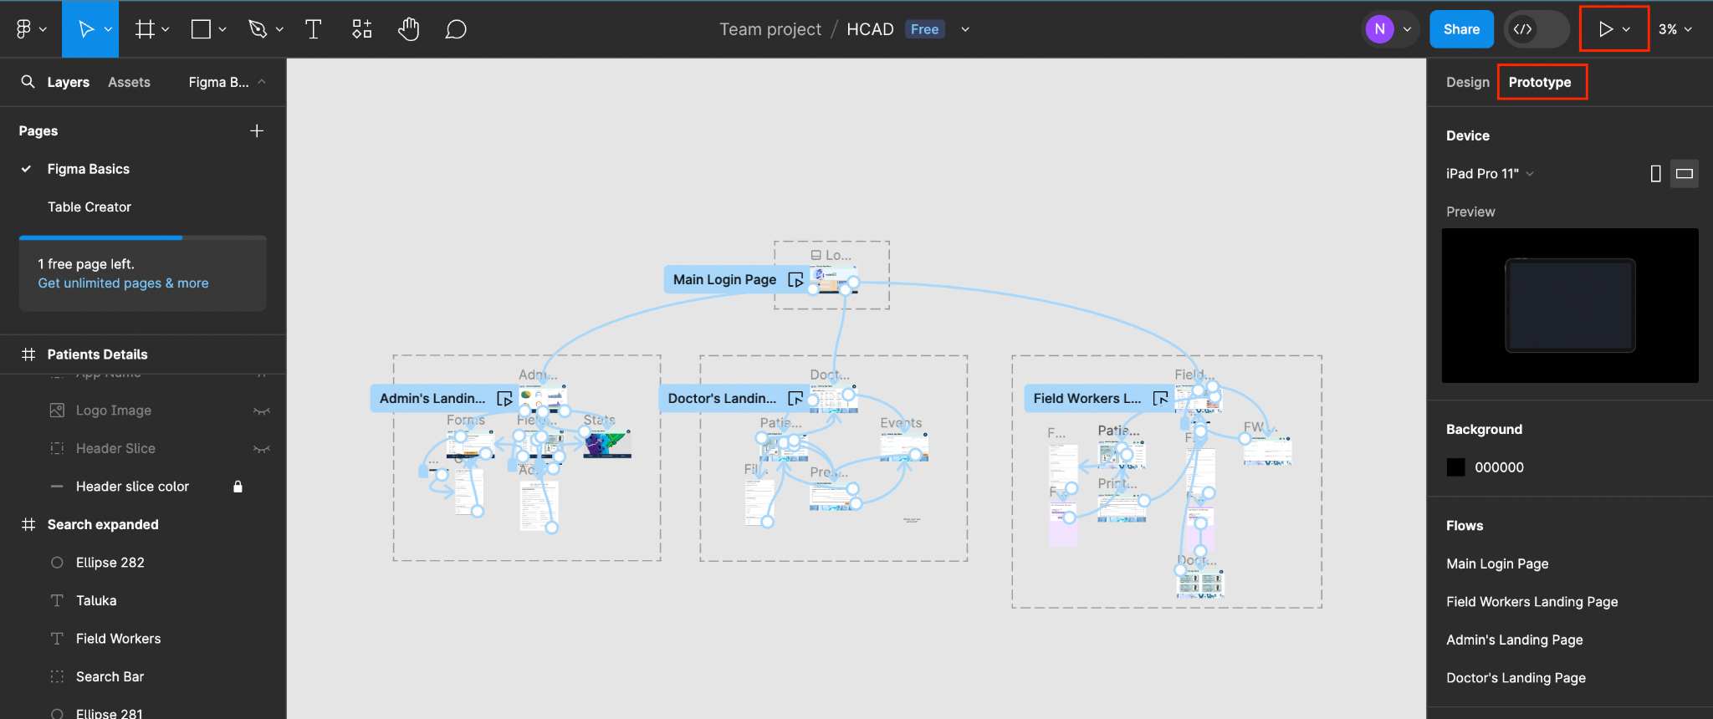

# Microservice Architecture

Services are talking to each other.

When an order has to be placed, we are going to check whether inventory is available or not by making a sync communication, once the order has been placed, we will send a notification by async communication.

API Gateway - acts as a gateway to send the request from users to diff services. For eg: if i want to communicate with product service, I don’t want to give the hostname or IP address of this service to the user, so API gateway will act as a gatekeeper to send out the request to diff services we like.

It also address some cross cutting concerns like authentication like if you want all the apis to be authenticated and security, also acts as a load balancer if we a lot of instances of our services

Tries to implement SSL termination, if actor calls the api gateway from outside with https scheme with tls protocol, the api gateway as it is already a part of the microservices network, as it is internal communication, we don’t need https there, so ssl communication will be terminated at the time of entry point of api request at api gateway level.

Spring cloud api gateway

Prometheus - extract metrics from our spring boot app and store it in our in memory database

Grafana - visualize this metrics using grafana

Spring boot actuator

Prometheus acts like a datasource for grafana

To do centralised logging, we use elasticsearch and kibana.

King kong

Hl proxy